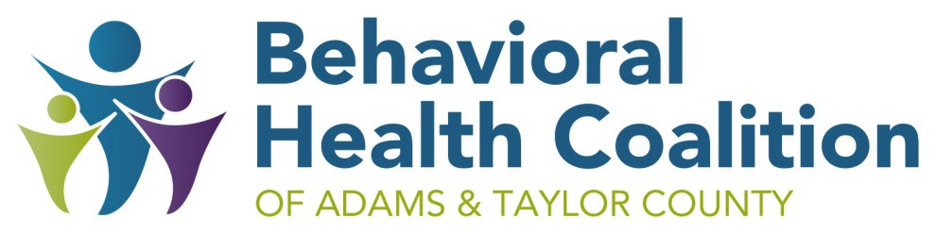
Meeting Minutes
CHI Health Mercy Corning
Held Virtually
October 1, 2020 (11:45 A.M. – 12:40 P.M.)

Attendance at the meeting:

Debra Schrader, Coalition Leader
Brittany Shinn, Crisis Intervention
Taylor Lynch, MATURA Head Start
Lori Henrichs, ISU Extension
Lisa Carstens, Zion
Gina Moulas, Omaha VA Medical
Liz Timmerman, Southwest Valley School
Vicki Sickels, Quad Counties 4 Kids
Dawn Walton, Zion
Kris Richey, Southwest Iowa Mental Health Region
Joyce Westphal, therapist
Kristie Nixon, SWCC
Chelsea Sorenson, Crossroads
Mary O’Riley, Prescott Church
Courtney Neal, Matura 1st Five

Materials
Coalition meeting materials are in Google Drive, and they are located here. Agendas and minutes are located at https://behavioralhealthcoalition.org/.

Welcome/Introductions
Debra Schrader opened the meeting and introductions made.

Review of meeting minutes
The minutes of the September 3, 2020 meeting were reviewed and accepted.

COVID-19 Update
New guidance for schools, child care and business was released September 29, 2020. More information is located here.

Proposed Collaborative Areas
1st Five, MCAH, WIC and I-Smiles will change in the FY22 request for proposal from IDPH. There will be larger service areas and they will not follow the same lines as past years. This may be difficult for some families to participate in programming due to the changes.

FY2021 Mission and Ministry Grant Updates
Contractor | Program | Updates
Taylor County ISU Extension | Parents as Teachers | Home visits continue to be conducted by an electronic platform. There were 21 families served with 48 virtual visits completed in September. At this time guidance is no face to face visits are to be conducted until October 16, 2020. Several referrals have been received, (i.e. self referral, 1st Five etc)
Southwestern Community College | Parents as Teachers | Home visits continue to be conducted by an electronic platform. There were 4 families served with 6 visits completed in September. At this time guidance is no face to face visits are to be conducted until October 16, 2020. They are in need of referrals.
DD Consulting & LT Consulting | Nurtured Heart Approach | Virtual book studies have been implemented with Corning and Villisca elementary teachers. Six hour trainings will be conducted virtually. Input was sought from the Coalition regarding allowing others from outside Adams and Taylor County to attend trainings. It was consensus this would be allowed with the caveat that Adams and Taylor County participants take president if training reaches capacity. It was also consensus participants outside of Adams and Taylor County be required to pay for their own materials.  It was noted that Tinker Tots is interested in training.
Joyce Westphal | Infant & Early Childhood Mental Health Consultation | Training will be offered to preschools, child care centers and home providers in October.  Training will be offered to family support programs on mood disorders and evaluation tools.
Crisis Intervention & Advocacy | Sexual Abuse Prevention | Brittany is working with the schools and training will be done electronically.
Southwest Valley Schools | Technology | The OWLS technology is not as effective as other products. Promethean boards are better for remote learners and are more intuitive. Promethean boards will be purchased instead of OWLS that will serve Kindergarten through 5th grade. The same performance measures will be utilized and it does not change the intent of the project.
Coalition Members | Outreach Efforts | There will around $700 in this line item after the website expenses are paid for and could be utilized for the new ACEs booklets.

Budget Updates
The FY21 year grant is $168,892 at which 13% has been expended. The October expenses have yet to be turned in.

Violence Prevention Gant
Deb has drafted the Violence Prevention grant letter of intent utilizing the FY21 letter of intent. Mission and Ministry has not posted the information for FY22 letter of intent and Deb will be monitoring the website for information. Potential contractors have provided Deb with the needed information with the exception of Connections Area on Ageing. Other programming ideas such as addressing human trafficking may would be beneficial.

Other Updates
- Lisa Carstens from Zion Recover shared work that was done around gambling prevention in a 7 county area. Retailers who sell lottery tickets were provided training and resources.
- Dawn Walton fro Zion Recovery shared 3.9% of high school student misused Adderall in the last year. October 24, 2020 is Take Back Drug Day.
- Mary O’Riley reported the Prescott Church opened up on June 7th for face to face services.

Next Meeting
Meeting adjourned at 12:4 P.M. The next meeting is November, 2020 and will be a Zoom meeting.
Respectfully submitted, Debra Schrader, CHI Coalition Leader.

