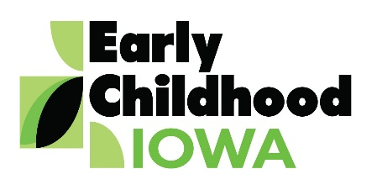 Quad Counties 4 Kids MEETING AGENDA
Wednesday, March 27, 2019--6:00 p.m.
FINANCE COMMITTEE WILL MEET AT 5:30 PM

Serving children and families in Adams, Ringgold, Taylor and Union Counties
Creston Elementary School, 805 Academic Avenue, Creston, Iowa
Introductions | Information
Additions/Approval of Agenda | Action Required
Approval of minutes from February 20, 2019 | Action Required
Professional Development  - Report from SWCC—Parents as Teachers Adams/Union Counties | Information
Report from the Finance Committee  - Approval of claims since last meeting | Action Required
Contract Amendments  - Taylor and Adams County Family Support Programs | Action Required
FY2020 Budget  - Preliminary EC & SR funding estimates | Information
Early Childhood Centers  - Discussion & Possible Funding | Possible Action Required
Early Childhood Advocacy  - Association of Early Childhood Iowa Boards Proposal | Action Required
SWOT Analysis  - Report | Information
WAGE$ Program  - Information | Information
Preschool Development Grant  - Focus groups | Information
Director Report/Discussion  - Calendar  - Scholarship Report  - Central Slice Day on the Hill  - Nurtured Heart Approach Report Lenox  - Other | Information
Public Comments/Agency Sharing
Persons wishing to address the boards are requested to identify themselves and state the matter
on which they wish to comment. The boards will appreciate your cooperation in keeping your
comments brief. Please observe the time allocated by the board chair.
Meeting Schedule  - Schedule Orientation for New Board Members  - May 22, June 26, No meeting in July  - RFP committee meeting in April 29 | Information
Adjourn

Contact person: Vicki Sickels, Director | Quad Counties 4 Kids Early Childhood Area| vsickels@windstream.net |807 W. Columbus Street | Mount Ayr, IA 50854| Cell: 515-868-8729 | phone or text

Board Members:
If you wish to be listed as excused from the meeting, please notify me via email, phone or text.

