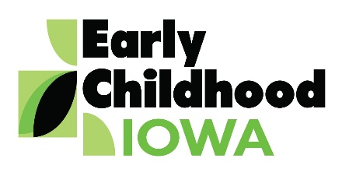 Quad Counties 4 Kids MEETING AGENDA
Wednesday, February 20, 2019--6:00 p.m.
FINANCE COMMITTEE WILL MEET AT 5:30 PM

Serving children and families in Adams, Ringgold, Taylor and Union Counties
Creston Elementary School, 805 Academic Avenue, Creston, Iowa
Introductions | Information
Additions/Approval of agenda | Action Required
Approval of Minutes October 29, 2018 Meeting | Action Required
Approval of new Board Member  - Tasha Moore representing Ringgold County | Action Required
Report from the Finance Committee  - Approval of claims since last meeting | Action Required
Contract Amendments  - Taylor and Adams County Family Support Programs | Action Required
Nurtured Heart Approach  - Taylor County | Information  Action Required
Provider Grants  - In-home provider  - Centers  - Preschool | Action Required
Program Reports from Family Support Programs  - Review semi-annual data | Information
SWOT Analysis | Information
FY2020 RFP  - Appoint RFP Committee  - RFP Timeline | Information
Director Report/Discussion  - Calendar  - Scholarship Report  - Nurtured Heart Approach Report (Creston & Mount Ayr)  - ICAP Safety Grant Update  - Families First Act  - Federal Preschool Development Grant-State  - Other | Information
Professional Development  - Agency Updates  - Board member activities | Information
Public Comments/Agency Sharing
Persons wishing to address the boards are requested to identify themselves and state the matter
on which they wish to comment. The boards will appreciate your cooperation in keeping your
comments brief. Please observe the time allocated by the board chair.
Meeting Schedule  - March 27 (?), May 22 (RFP committee meeting in April) | Information
Adjourn

Contact person: Vicki Sickels, Director | Quad Counties 4 Kids Early Childhood Area| vsickels@windstream.net |807 W. Columbus Street | Mount Ayr, IA 50854| Cell: 515-868-8729 | phone or text

Board Members:
If you wish to be listed as excused from the meeting, please notify me via email, phone or text.

