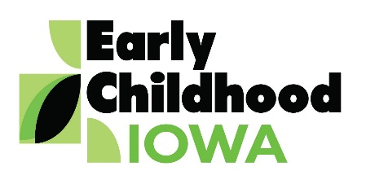 Quad Counties 4 Kids MEETING AGENDA
Wednesday, October 24, 2018--6:00 p.m.
FINANCE COMMITTEE WILL MEET AT 5:30 PM

Serving children and families in Adams, Ringgold, Taylor and Union Counties
Creston Elementary School, 805 Academic Avenue, Creston, Iowa
Introductions | Information
Additions/Approval of agenda | Action Required
Approval of Minutes August 29, 2018 Meeting | Action Required
Report from the Finance Committee  - Approval of claims since last meeting | Action Required
Contract Amendments  - Taylor and Adams County Family Support Programs | Action Required
Nurtured Heart Approach  - Union, Ringgold and Taylor Counties | Action Required
Program Reports  - Review if available | Information
Re-designation Process Discussion  - October 31, 2020—the following documents are required:  Comprehensive community needs assessment  Comprehensive community plan  Area Board strategic plan (if different from community plan) | Information
Director Report/Discussion  - Calendar  - Scholarship Report  - CCNC Update  - Site Visit for Contract Review  - Early Childhood Systems Summit  - State ECI Director Meeting | Information
Professional Development  - Agency Updates  - Board member activities | Information
Public Comments/Agency Sharing
Persons wishing to address the boards are requested to identify themselves and state the matter
on which they wish to comment. The boards will appreciate your cooperation in keeping your
comments brief. Please observe the time allocated by the board chair.
Meeting Schedule  - January 30, March 27, May 22 | Information
Adjourn

Contact person: Vicki Sickels, Director | Quad Counties 4 Kids Early Childhood Area| vsickels@windstream.net |807 W. Columbus Street | Mount Ayr, IA 50854| Cell: 515-868-8729 | phone or text

Board Members:
If you wish to be listed as excused from the meeting, please notify me via email, phone or text.

