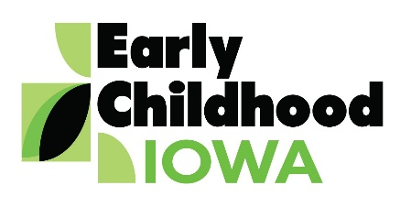 Quad Counties 4 Kids MEETING AGENDA
Wednesday, August 29, 2018--6:00 p.m.
FINANCE COMMITTEE WILL MEET AT 5:30 PM

Serving children and families in Adams, Ringgold, Taylor and Union Counties
Creston Elementary School, 805 Academic Avenue, Creston, Iowa

Introductions | Information
Additions/Approval of agenda | Action Required
Approval of Minutes May 23, 2018 Meeting | Action Required
Board Membership  - Approval of Kristyn Mercer board membership  - Reappointments to board (Jenny Robinson, Kathy Ralston) | Action Required
Report from the Finance Committee  - Approval of Final Financial Statements FY2018  - Approval of FY2019 Claims | Action Required
Additional FY2019 RFP  - Approval of RFP for CCNC services Marion County PH | Action Required
Fy2018 Annual Report  - Review and consideration of approval | Action Required
Evaluations  - Board Member Self-evaluation  - Director Evaluation | Information
Board Membership  - Update on recruitment | Information
Director Report/Discussion  - Calendar  - Scholarship Report  - HHS Grant Application Partnership  - Nurtured Hearts Approach  - Other | Information
Professional Development  - Agency Updates  - Board member activities | Information
Public Comments/Agency Sharing
Persons wishing to address the boards are requested to identify themselves and state the matter
on which they wish to comment. The boards will appreciate your cooperation in keeping your
comments brief. Please observe the time allocated by the board chair.
Meeting Schedule  - October 24, January 30, March 27, May 22 | Information
Adjourn

Contact person: Vicki Sickels, Director | Quad Counties 4 Kids Early Childhood Area| vsickels@windstream.net |807 W. Columbus Street | Mount Ayr, IA 50854| Cell: 515-868-8729 | phone or text

Board Members:
If you wish to be listed as excused from the meeting, please notify me via email, phone or text.

