Quad Counties 4 Kids MEETING AGENDA
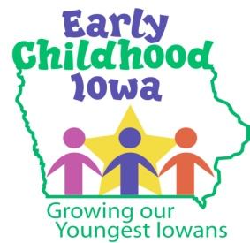
Wednesday, March 28, 2018--6:00 p.m.
FINANCE COMMITTEE WILL MEET AT 5:30 PM

Serving children and families in Adams, Ringgold, Taylor and Union Counties
Creston Elementary School, 805 Academic Avenue, Creston, Iowa

Introductions | Information
Additions/Approval of agenda | Action Required
Approval of Minutes January 24, 2018 Meeting | Action Required
Report from the Finance Committee  - Approval of Vouchers | Action Required
ICAP Insurance Renewal  - Renewal of Insurance – if available | Action Required
CCNC Services  - Approve Contract with Decatur Co PH for CCNC services for Ringgold County only | Action Required
Safety Item Funding  - Additional money for safety items | Action Item
RFP & Mini-Grant Update  - ICAPP Grant Update  - RFP Issued March 9, due April 16, 4:00 PM  - In-home provider list to-date  - Preschool & Center mini-grants due Friday, April 20 | Information
Director Report/Discussion  - Calendar  - MCO Partnership Meeting  - ICAP Insurance $1,000 grant update  - Site Visits  - Regional Director Meeting Update | Information
Professional Development  - Board Member Self-Assessment (Annual) | Information
Public Comments/Agency Sharing
Persons wishing to address the boards are requested to identify themselves and state the matter
on which they wish to comment. The boards will appreciate your cooperation in keeping your
comments brief. Please observe the time allocated by the board chair.
Meeting Schedule  - RFP Committee meeting April 25 at 6:00 PM Pizza Ranch  - May 23 and June 27 | Information
Adjourn

Contact person: Vicki Sickels, Director | Quad Counties 4 Kids Early Childhood Area| vsickels@windstream.net |807 W. Columbus Street | Mount Ayr, IA 50854| Cell: 515-868-8729 | phone or text

Board Members:
If you wish to be listed as excused from the meeting, please notify me via email, phone or text.

