Quad Counties 4 Kids MEETING AGENDA
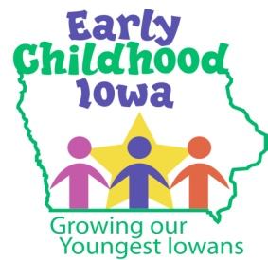
Wednesday, January 24, 2018--6:00 p.m.
FINANCE COMMITTEE WILL MEET AT 5:30 PM

Serving children and families in Adams, Ringgold, Taylor and Union Counties
Creston Elementary School, 805 Academic Avenue, Creston, Iowa

Introductions | Information
Additions/Approval of agenda | Action Required
Approval of Minutes October 24, 2017 Meeting | Action Required
Report from the Finance Committee  - Approval of Vouchers | Action Required
Program Reports  - If available | Information
Budget Amendment  - State budget update  - Mini-grants (preschool/centers/in-home providers) | Information  Action Required
Proposed By-Law Change  - Second reading | Action Required
Election of Officers for Calendar Year 2019  - Chair, Vice Chair & Recording Secretary | Action Required
Board Memberships  - Recruitment | Information
RFP Committee Member Appointments  - 3-4 Board Members  - Timeline | Information/Action
Early Childhood FY2019 Preliminary Funding  - New formula phase-in | Information
Director Report/Discussion  - Preschools update  - Adams/Taylor County Behavioral Health Coalition-website  - ECI Core Services  - PCA Iowa Needs Assessment—RFP for FY2019  - ICAP Insurance Grant  - CCNC update for Ringgold County only | Information
Professional Development  - Child Care Data 2012-2017  - Why Child Care Matters to Iowa Businesses  - State ECI Board PPP Committee | Information
Public Comments/Agency Sharing
Persons wishing to address the boards are requested to identify themselves and state the matter
on which they wish to comment. The boards will appreciate your cooperation in keeping your
comments brief. Please observe the time allocated by the board chair.
Meeting Schedule  - 2018: March 28—May 23—June 27 | Information
Adjourn

Contact person: Vicki Sickels, Director | Quad Counties 4 Kids Early Childhood Area| vsickels@windstream.net |807 W. Columbus Street | Mount Ayr, IA 50854| Cell: 515-868-8729 | phone or text

Board Members:
If you wish to be listed as excused from the meeting, please notify me via email, phone or text.

