Quad Counties 4 Kids MEETING AGENDA
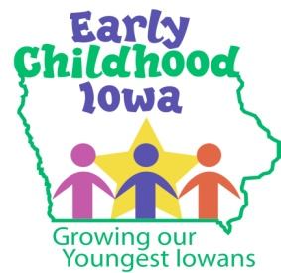
Wednesday, October 25, 2017--6:00 p.m.
FINANCE COMMITTEE WILL MEET AT 5:30 PM

Serving children and families in Adams, Ringgold, Taylor and Union Counties
Creston Elementary School, 805 Academic Avenue, Creston, Iowa

Introductions | Information
Additions/Approval of agenda | Action Required
Approval of Minutes August 23, 2017 Meeting | Action Required
Report from the Finance Committee  - Approval of Vouchers | Action Required
Request for Med Management Training Funding  - Training is scheduled for Saturday, October 28 | Action Required
Program First Quarter Reports  - If available | Information
Mid-designation period contract file review  - Shanell Wagler reviewed requested files October 19  SWCC (PAT and Fall Early Childhood Conference)  MATURA (CCNC and Dental) | Information
Proposed By-Law Change  - First reading | Information
Director Report/Discussion  - Preschool Scholarship Report  - Nurtured Hearts Approach Training  - Prevent Child Abuse County Alignments  - Other | Information
Professional Development  - SWCC Parents as Teachers program information | Information
Public Comments/Agency Sharing | Information
Persons wishing to address the boards are requested to identify themselves and state the matter on which they wish to comment. The boards will appreciate your cooperation in keeping your comments brief. Please observe the time allocated by the board chair.
Meeting Schedule  - 2018: January 24—March 28—May 23—June 27 | Information
Adjourn

Contact person: Vicki Sickels, Director | Quad Counties 4 Kids Early Childhood Area| vsickels@windstream.net |807 W. Columbus Street | Mount Ayr, IA 50854| Cell: 515-868-8729 | phone or text

Board Members:
If you wish to be listed as excused from the meeting, please notify me via email, phone or text.

