Quad Counties 4 Kids MEETING AGENDA
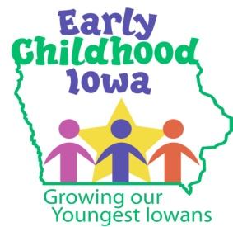
Wednesday, August 23, 2017--6:00 p.m.
FINANCE COMMITTEE WILL MEET AT 5:30 PM

Serving children and families in Adams, Ringgold, Taylor and Union Counties
Creston Elementary School, 805 Academic Avenue, Creston, Iowa

Introductions | Information
Additions/Approval of agenda | Action Required
Approval of Minutes June 28, 2017 Meeting | Action Required
Report from the Finance Committee  - Approval of Vouchers—year end 2017  - Approval of Vouchers--2018 | Action Required
Annual Report  - Financial Statements  - Program Reports | Action Required
Request from I Think I Can  - National Administrator’s Credential training expenses | Action Required
Board Membership | Action/Information
Director Report/Discussion  - Preschool Scholarship Report  - GSF Re-credentialing  - Prevent Child Abuse Funding  - Family Support Update | Information
Professional Development  - New Designation Process | Information
Public Comments/Agency Sharing | Information
Persons wishing to address the boards are requested to identify themselves and state the matter on which they wish to comment. The boards will appreciate your cooperation in keeping your comments brief. Please observe the time allocated by the board chair.
Meeting Schedule  - October 25, 2017  - 2018: January 24—March 28—May 23—June 27 | Information
Adjourn

Contact person: Vicki Sickels, Director | Quad Counties 4 Kids Early Childhood Area| vsickels@windstream.net |807 W. Columbus Street | Mount Ayr, IA 50854| Cell: 515-868-8729 | phone or text

Board Members:
If you wish to be listed as excused from the meeting, please notify me via email, phone or text.

